**Sustainability Series: Session 3**

**Creating a Legacy**

**Suicide Prevention Resource Center’s Workshop Series for 2nd Year GLS Grantees**

**Tuesday, August 5, 2014, 3-4:30 p.m. ET**

Recording Link: <http://edc.adobeconnect.com/p2lmzai8l69/>

**Lobby Poll:**

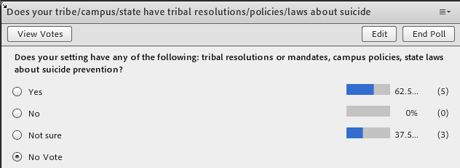

**Strategies and Roadblocks Discussion**

***How will you gain/maintain resources and tools?***

* work with rising freshman to identify future leaders on campus
* looking into student organizations
* forming coalitions with student representatives

Rachelle Burns: Collaboration with various departments on campus (community college) - particularly working with Student Activities

Jenny Stephens: We're building relationships with faculty to tap into that resource. By building these relationships, we're finding that professors are willing to let us come in and talk to their classes, and some are even having us come in and present QPR training. This is something that we'll be able to do beyond the grant ending.

Rachelle Burns: Do you have a student club or organization like Active Minds?

Michelle Zelaya: Sources of Strength is a program that is helping us in GA to change norms, reduce stigma and increase the colaboration between several departments

Linda Wolszon: At TCU, students start a Mental health Blog, called "FrogsSpeak" where students can post their experiences with depression, anxiety, thoughts of suicide, and how getting help was OK.

***How will you leverage existing partners/which new ones will you approach?***

* Partnership with other local suicide prevention program that focused on Native Americans

Rachelle Burns: In terms of leveraging partnerships, we are using our existing relationships with local mental health agencies to create a community coalition, which, as a community college, is an important step for us.

Jenny Stephens: I think it will be helpful to keep my advisory board going. The advisory board has led to a lot of collaborations with various faculty/staff on campus.

Rachelle Burns: We are expanding beyond community mental health to include local law enforcement, local hospitals and the local homeless coalition.

jonathan williams: We have been increasing our student involvement by integrating the marketing majors to host and design a capturing hope 1 and 2.0 where students are taking photos around campus with their chosen positive encouragement statements. The turnout has been very good. The photos are posted later throughout the campus year round

Kathleen Pignatelli: Thanks to all for sharing. It is helpful

***Who should you keep informed? How will you do it?***

- Need to keep people informed and engaged, information as to how the program is impacting people. Using champions.

- Sometimes someone outside the program communicating your successes can have more impact