
Sustaining the Legacy of Your Suicide Prevention Efforts
A Guide to Getting Started With Sustainability Planning

‘Sustainability’ seems like a simple concept, but in fact it can include many strategies and approaches. We all need funding to continue programs, but how can we share responsibilities and resources in a way that takes us beyond a single grant or funding stream? Whether your grant is focused on urban, rural, state, tribal or campus settings, there are common questions and experiences we can share in sustaining our work in suicide prevention.

How to Use This Guide
The purpose of this sustainability guide and accompanying tools is to help you formulate a 1 – 2 year sustainability plan. Because the environment will continue to change, we recommend that your planning group and stakeholders plan to come together every few years to recognize and celebrate successes, as well as to reprioritize the work moving forward.

As a grantee, you already have set goals, objectives and strategies which are most likely reflected in your workplan. Before going further, we recommend that you review your grant workplan and logic model, since they will be helpful references as you go through this guide.

Tools
We’ve provided an excel file with the following tools to use in your sustainability planning. We’ll refer to them throughout this guide:
- The Big Picture Worksheet (blank)
- The Big Picture Worksheet with example
- Taking Objectives Off Your List (blank)
- Taking Objectives Off Your List with example
- Sustainability Action Plan (blank)
- Sustainability Action Plan with example


We’ll use this icon whenever we ask you to use a worksheet in your planning process.

The Big Picture
In planning for sustainability, it’s easy to get preoccupied with continuing existing activities, protecting people’s jobs, and trying to replace every dollar of the original grant. But for many, suicide prevention after the grant ends looks quite different than it did during the life of the grant.

As you go through the sustainability planning process, remember: Your goal is to sustain improving suicide prevention. What that looks like may change over time, but keeping an eye on that ultimate endpoint can help you step back from specific activities and personnel to make a plan that has impact beyond the end of the grant.
Terminology
Grants can vary in level of detail and how terms like “goals” and “objectives” are defined. Terms used in your grant proposal may differ from what we use here. For our sustainability planning work, we’ll use the following terms and definitions:

Goal: The ultimate endpoint you’re trying to get to.
For most of our work, the goal is lowering the rate(s) of suicide deaths and behaviors.

Outcome: The big picture change to risk and protective factors that will help you achieve your goal.
For example:
- “Improve youths’ problem-solving skills.”
- “Increase at-risk youths’ access to mental health services.”

For this we will also use the phrases “Bigger picture change” and “Priority change.”

Speaking the same language
Grantees often use the terms “goals” and “objectives” to mean very different things. We recommend matching up your grant goals and objectives with our definitions before you begin planning. For example:
- If objectives in your grant were broader than our definition (something like ‘School-Based Prevention’), it will be helpful to reframe them in SMART terms.
- Or you may have named goals that match up with what we’re calling objectives. For this process, we’d like to ask you to call those items objectives.

Objective: A concrete piece of work that will help you accomplish your goal.
Your grant may identify objectives that are framed broadly, such as:
- “In schools, conduct evidence-based youth training on suicide prevention that includes problem solving skills.”
- “In high-risk settings, train gatekeepers to identify at-risk youth and refer them to mental health services.”

For our sustainability planning work, we recommend using SMART objectives (Specific, Measurable, Attainable, Realistic, and Time-bound).
For example:
- “Implement X student life skills training from the Best Practices Registry with 8 schools in the 4 counties that have the highest suicide rates in the state by June 2014.”
- “Conduct gatekeeper trainings with 250 staff of juvenile justice facilities in Years 2-3.”

Activity: The smaller steps needed to accomplish the objective.
For example:
- “Get school administrators’ agreement to implement program.”
- “Train teachers to deliver the student curriculum.”
Planning for Sustainability – A Model
This guide will take you through seven steps of sustainability planning, as illustrated in the diagram below. Although we will take you through a sequential process, you may need to go back to earlier steps to be able to move forward. The larger arrows identify some specific steps where it’s likely you may need to re-check your priorities and objectives once your action planning has begun.

2. Relate Objectives to Outcomes
7. Put your Plan into Action
1. Assess Current Objectives
3A. See What’s Already Sustained
3B. Prioritize
What Else to Sustain

4. Make New SMART Objectives
5. & 6. Plan How and Who
Will Act

Step 1: Getting Started
Start by going back to your grant objectives in your grant application, work plan, or logic model. You can use the accompanying worksheet “Sustaining Suicide Prevention Work: The Big Picture” to write down your thoughts as you go through each step in this guide. For each objective in your grant (see definition above), ask yourself the following questions:

- Has the project been successful in meeting this objective?
  - How do we know if it succeeded or didn’t?
  - Is there any data to help us determine how successful we were?
  - What changed after this objective was implemented (what impact did it have)?

- Were there challenges that changed the objective or prevented success?
  - What challenges or barriers arose?
  - How did we modify our approach?
  - Were we able to make any progress in this area?

- Which parts of this objective’s work have momentum?
  - What has helped it move forward?
  - Whose support has been key?

Fill in the first four columns on the “Big Picture” worksheet for each objective.

Step 2: Affecting the Bigger Picture
When you’re thinking about sustaining suicide prevention, it can be helpful to focus on the bigger picture changes you are hoping for, rather than just on specific objectives. This can help you figure out which of your grant objectives were the most successful, by looking at how they decreased risk factors and increased protective factors. Focusing on this level of change can also help your team come up with new ways of supporting protective and reducing risk factors once the grant is over (so you don’t have to be tied to just continuing existing grant activities).

Take a step back to look at how each objective relates to the big picture of reducing suicide risk factors and increasing protective factors.
Which risk factor, and/or protective factor was each objective hoping to change?

For example:

If Your Objective Was:
Implement new anti-bullying policies in 10 schools by January 2012
Provide gatekeeper training to 150 school staff by October 2011
You Might Be Trying to Change:
Increasing social support and connectedness in the school setting
Identifying at-risk youth and referring them to services
Increasing access to services for at-risk youth
Reducing barriers to at-risk youth accessing services

For each objective listed on your “Big Picture” worksheet, write the corresponding big picture outcome in the fifth column.

Step 3: Prioritizing Outcomes and Objectives Moving Forward
Ideally, you would find funding to continue everything you’re doing. But in these financially tight times, it’s important to assume you won’t be able to replace the grant, dollar for dollar. So it’s helpful to consult with your Task Force, Planning Group, Coalition, or other stakeholders to prioritize outcomes and objectives that are at the top of your list to continue in some way.
In Year 2 of their grant, Site A met with their advisory board to begin sustainability planning. School-based gatekeepers had been referring at-risk youth, and the advisory board reported that students and staff loved the trainings, so they decided to make school trainings a high priority. However, the state Department of Education was not open to discussing mandated crisis response protocols, so the group decided to take that off the list, to revisit in 2 years when the administration has changed.
3A: Taking Objectives Off Your List
First, you can take some program objectives off of your list entirely. For example:
- Objectives that were achieved (e.g. all the Mental Health clinicians in the area have been trained) may not need attention moving forward, or will only come up again a few years from now. Ask yourself if the need for that program still exists; if not, take the program off your list for the current sustainability plan (you can revisit it in your next planning cycle).
- Objectives that are now institutionalized; meaning they have been built into the regular operations, policies, or protocols of your organization or partner agencies. In some cases, these objectives may be built into MOUs or legislation. These objectives should now continue without further programming or investment from your group.

Recognize and celebrate objectives that have been achieved or institutionalized! These key programs and activities will now be sustained for the next few years, so you don’t need to include them in your current plan.

Fill in the “Taking Objectives Off Your List” worksheet for each objective.

3B: Prioritizing Where to Focus Your Efforts Moving Forward
Now comes the harder part: prioritizing remaining outcomes and objectives to decide whether or how to continue them. Basically, you’re hoping to get the biggest ‘bang for your buck,’ by prioritizing existing, modified, or new objectives based on what will create the biggest change for the smallest cost (in terms of money, people, and time). Balance the importance with the “do-ability.”

To prioritize your sustainability focus for the coming years, your group should work with stakeholders and partners to answer questions like:

- Which outcomes are most needed to create change in your community? Consult available data to determine:
  - What are the common risk factors of the youth in your area?
  - Which protective factors are missing for youth in your area?
  - Which of these risk and protective factors can be changed? And how?

- What objectives have been most effective?
To help your team prioritize, look at some relevant data for your tribe, area, state, campus, and/or focus population.

For national or state data on specific populations and states, learn more about data sources from SPRC’s free online course on using data for strategic planning, at http://training.sprc.org/

To identify college/university data sources, we recommend the EDC/Jed Foundation Guide to Campus Mental Health Action Planning http://www.sprc.org/sites/sprc.org/files/library/CampusMHAP_Web%20final.pdf (pp.9-11)

  - What has had the biggest impact on reducing risk and increasing protective factors?
  - How do you know the impact of those objectives?

- For ineffective or unsuccessful objectives, is the hoped-for outcome still a priority?
  - If so, how could you move forward with addressing this priority through a new or adjusted approach?

- What objectives can be most easily achieved?
  - What is most supported/valued by the community?
  - What effort is most likely to create change?
  - What would bring the biggest change for the investment (where would resources be best spent to have the biggest impact)?

For each listed outcome in column five of your “Big Picture” worksheet, describe reasons for its priority in the top box of the sixth column.

In column six, lower box, rank each objective as high, low, or already sustained. List the reason for that priority ranking.

For your sustainability plan, you will focus on the ones your planning team has decided are high priority objectives. Keep the rest for your next planning cycle. With limited resources, you can’t do everything.

Step 4: How Will You Work On These Changes Going Forward?
How will you sustain your top priority outcomes going forward? It can be helpful to stop and think about creative ways of sustaining these changes. Take each newly-prioritized outcome and turn it into a SMART objective, taking time to consider other ways of achieving your outcome. If it is an existing objective that you are prioritizing, make any necessary tweaks to it.
Write the new SMART objectives in the last column of the worksheet “Big Picture” worksheet.
Step 5: Identify What You’ll Need to Accomplish Your Priorities:
Now it’s time to plan out what actions, resources and partners will be needed to sustain your priority objectives and outcomes.

In order to figure out HOW you will sustain your new objectives, take your new objectives from the last column on the right (Step 4, in blue), along with their related outcomes, from the second or third to last column on the right (Step 3B, in red).

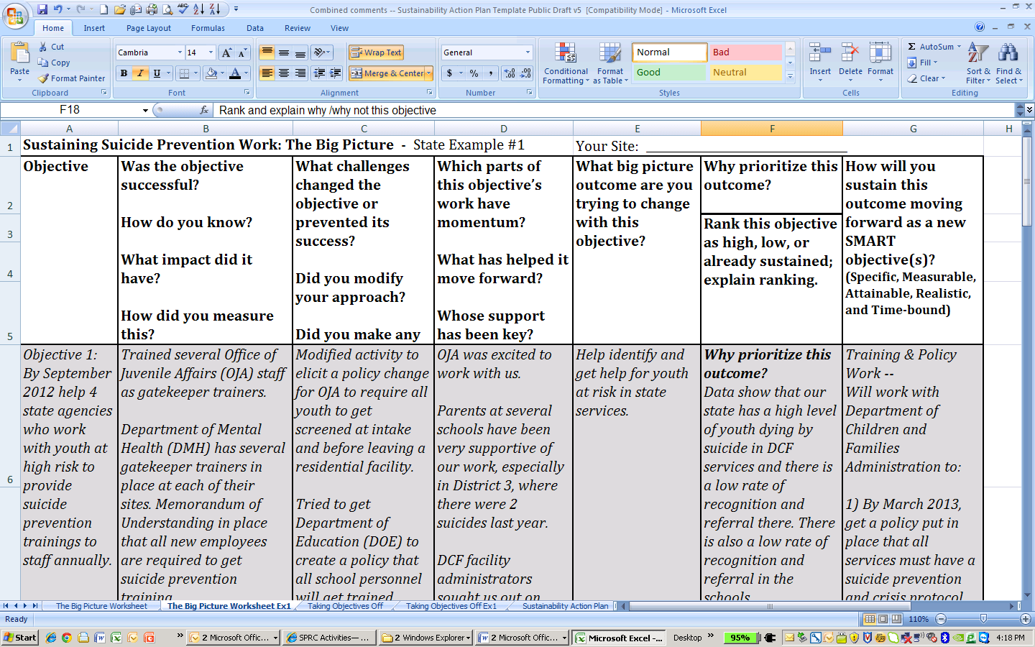

Plug them into the “Sustainability Action Plan” worksheet in the corresponding spots.

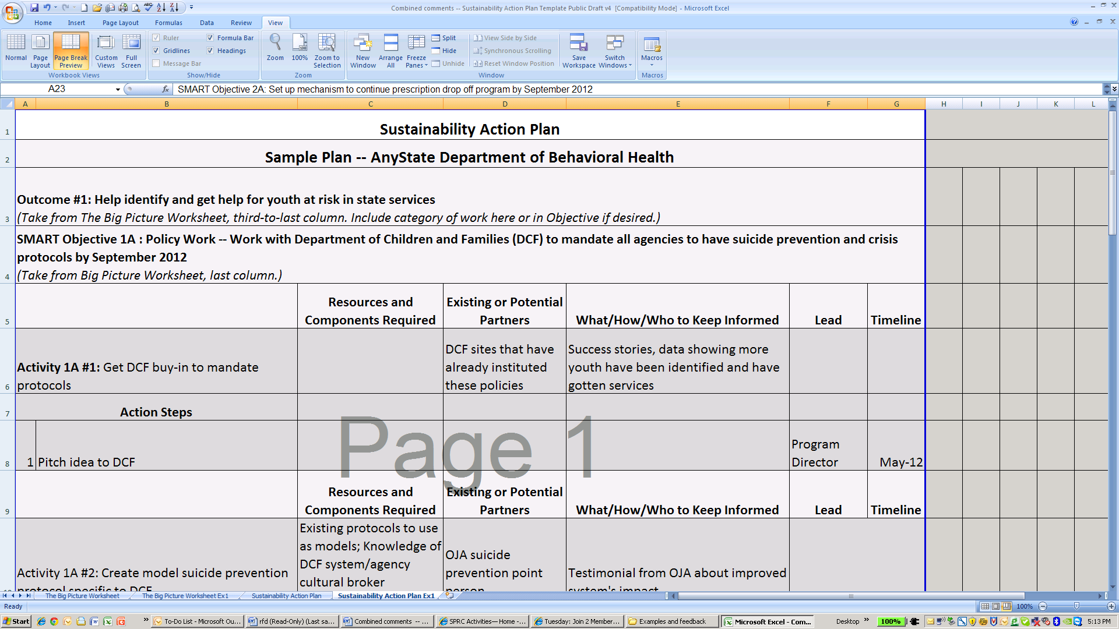

Step 6: Decide How You Will Get the Resources You Need to Accomplish Your Priorities:
At this point, you’ve filled out the main headings of the table – the question is: how will you accomplish your objectives in an ongoing way without the current grant funding? Now is the time to get creative and to think not just about other funding sources, but your partners, champions, resources and allies.
A useful tool for thinking broadly about strategies to sustain your priority objectives is The Legacy Wheel. This tool can help you and your planning team think about creative approaches to support priority areas, such as how to use Leadership for change, Partnerships and Collaboration, Evaluation, and more for sustainability. There is also a version specifically tailored for use in AI/AN settings.

The Legacy Wheel: http://sshs.promoteprevent.org/implementing/sustainability/legacy-wheel
The Legacy Wheel (adapted for use by Tribal programs): http://www.tribalyouthprogram.org/tools/legacy-wheel

Ask yourself the following questions about each objective:
- What activities go into accomplishing your objective?
- Can your entity support the work using other funding/operational resources?
- Are there partners or stakeholders could take on an activity or part of one? (Think about existing partners and also others who may have a vested interest and resources to help)
- Do partners have the capacity to do these activities? If not, how could their capacity be strengthened?
- Could policy changes cause the activity to happen automatically (i.e. institutionalize the task)?
- Is there a way to pay for an activity, or parts of it, through in-kind contributions (e.g. meeting space, staffing, volunteer time, etc.)?
- Are there leaders/champions who could help obtain additional resources?

On the “Sustainability Action Plan” worksheet, fill in the activities, partners and resources (funding and in-kind) that could help continue your priority objectives.

Step 6A: Communicate Your Needs and Successes:
In order to keep current partners, champions, and leaders engaged, and to enlist new ones, it is critical to communicate your program’s track record and successes (past and new) in an ongoing way.

In a way, you’re ‘selling’ your program, persuading someone to invest time, resources, or funding by explaining why it should matter to them, and how it serves their interests. You’re also keeping current supporters motivated by celebrating successes, and ensuring aware of your efforts so that they can continue to promote them. Remember that everyone is coming from a different perspective, with different priorities, and try to frame your work in a way that will resonate with what is important to each partner.

Include this as part of your Sustainability Action Plan by saying who you need to ‘sell’ to, and who you need to keep motivated. Note who on your staff will take a lead on this.

Step 6B: Set a Timeline:
How long will it take you/your project staff/your partners to accomplish each action step you’ll need to ensure sustainability of your priority objectives? Remember, anything that will take longer than 1-2 years can also be revisited in your next sustainability planning cycle.

Put this information into your Action Plan under ‘Timeline’.

A Cyclic Process

You may find after identifying what you need to accomplish your priorities (Step 5) that you simply do not have the resources or cannot identify partners to help sustain a priority objective. In that case, you may need to do one of three things:
Steps 1-3
Grantee Y was hoping to sustain their means restriction campaign by asking the state police take over advertising for their medication drop off program to local communities. However, the state police do not influence local police departments. Instead, they changed their approach to work with a statewide pharmacy chain to advertise the program in their prescription information inserts.

- You can change your approach to accomplishing the outcome (if possible).
- You may need to go back to Step 4 and change the objective to one that you can achieve more easily while still impacting your priority change.
- You may need to reprioritize and focus on an outcome that is more achievable (Step 3B).
- Then follow the steps again to create your action plan.

Don’t panic if you need to go back and re-think things – going back and forth between these stages is a part of the process of developing a realistic and achievable plan to sustain suicide prevention in your community.
2. Relate Objectives to Outcomes
7. Put your Plan into Action
1. Assess Current Objectives
3A. See What’s Already Sustained
3B. Prioritize
What Else to Sustain

4. Make New SMART Objectives
5. & 6. Plan How and Who
Will Act

Celebrate!
You’re well on your way to leaving a legacy of suicide prevention that will last beyond your current funding situation. Remember, the environment you’re working in will continue to evolve, with changing resources, staff capacity, community support, partnerships, and opportunities for funding and collaboration. To sustain your goal of suicide prevention, your planning group should repeat this process at least every 2 years, updating your plans as suicide rates, patterns, and local risk and protective factors change, new research comes out on effective approaches to save lives.

